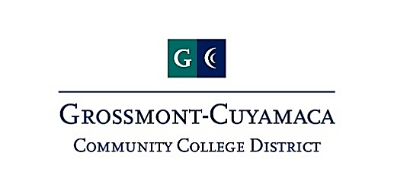
Human Resources Advisory Council
Minutes
Wednesday, March 1, 2023
(1:30 – 3:00 pm)
Zoom

Nashona Andrade
Nicole Conklin
Pearl Lopez
Karen Marrujo
Sharon Sampson

Aimee Gallagher
Bernadette Black
Cindy Hall
Colleen Parsons
Craig Leedham
Katie Cabral
Manuel Mancillas-Gomez

Topic | Notes
AP 7348 – Accommodations (Final read) | The committee reviewed AP 7348 as a final read. Several committee members suggested that creating a plan for lactation accommodation should also include notice or involvement from HR in addition to the immediate supervisor or manager. Katie suggested the use of a form as well. Sharon suggested that use of employee friendly language in lieu of stating “extended breaks may be reasonably denied.” The group suggested that in addition to locations, lactation rights should also be posted on the District website.
Presidents Selection AP/BP 7111 | Aimee brought back final suggestions on AP/BP 7111 and indicated that the Chancellor requested final feedback. The updates included replacement of the EEO site lead with the EEO Title IX officer in the final interview process; removal of District administrator but not at large member and continued community members to remain within the purview of the Board to select. Moriah and Manuel recommended that consideration be given to allowing the list of potential community members to be provided by the Senates rather than the Board. Board will then select from the Senate recommended list. Aimee to bring this back to the Chancellor for consideration.
AP 7130 – Compensation First Read | Aimee discussed the rationale for including more robust language and parameters surrounding equity in the current Compensation policy. Pearl inquired the reasoning behind prohibition on incentives and suggested that the legal citation be included. The group recommended language which would define when and how potential salary reviews would occur.
Standing Item – Equity in Employment Taskforce | Moriah reported that planning is continuing for the two day retreat in April at Cuyamaca College. Moriah also reported continued work on PE 13 as well as progress on the EEO/Title IX Officer recruitment. Karen gave an update on the next EEO rep training. Moriah discussed a recommendation from CCC that community members would be proposed by the chairs of the committee and the board would approve rather than have the board suggest it themselves. The committee composition was discussed at length. The end result was to have a balanced committee that was not too large or overbearing
Flexible Work Schedule Update | Craig gave an update on flexible work – simply stated it is still in negotiations with the unions. Katie asked about other districts who have started with a policy first and that they negotiated off of that. She wanted to know if we could do the same. Craig noted that it is a clear working condition and he doesn’t want to appear to get in front of union reps by creating a policy ahead of negotiating. Aimee may have to let everyone know by Friday that the current flexible extension may expire on March 3rd.
Aimee gave HR updates. The personnel commission meeting is tonight and the candidate that was interviewed may be approved for hire tonight.

The group each gave their own updates. Item of note, Katie shared an article: https://bsa.ca.gov/pdfs/reports/2022-113.pdf.

Next Meeting – March 22, 2022 | The group agreed to remain on schedule and meet on Wednesday, March 22 via zoom.

